1. Links to the Dataset: <https://www.kaggle.com/crizzi/are-happy-people-really-happy>
2. Description of audience (User, Problem, Scenario)

**User:**

Ms. Sharma is a data analyst of council in UN who publish happiness rank of country every year. Members of council have to create a dashboard for publishing the report. They are analysing the factors which are common in happy countries/ region and makes it top the list.

**Problem:**

All the countries have different happiness score. There are many factors which affect happiness of people i.e economy and GDP per capita, family, Government etc. The visualization will be helpful to see the areas which are common in countries where people are happy. It will provide the area of improvement for the people on that they can work to make their country at top of the list.

**Scenario:**

This visualization is to publish with report in magazine or newspaper where audience is common people. Their understanding of statistics is low. The target is to attract more people to read the article and show the areas of improvement.

The visualization should be in a way that will attract attention of people.

Below are the points on which visualization is based:-

* + - 1. Factors common in happiness of country in particular regions?
      2. Top 20 happiest countries in world.
      3. Analysis of happiest country.

1. **Link to the Dashboard from Tableau Public:**

<https://public.tableau.com/profile/rupal1308#!/vizhome/Assignment3_1_14/Dashboard1?publish=yes>

1. Paste screenshots of previous Iterations from Tableau Public

**Iteration 1:-**

* + - 1. Lot of extra information available on dash board.
      2. Two maps are not looking good.
      3. Colours are not common in factors affecting happiness.

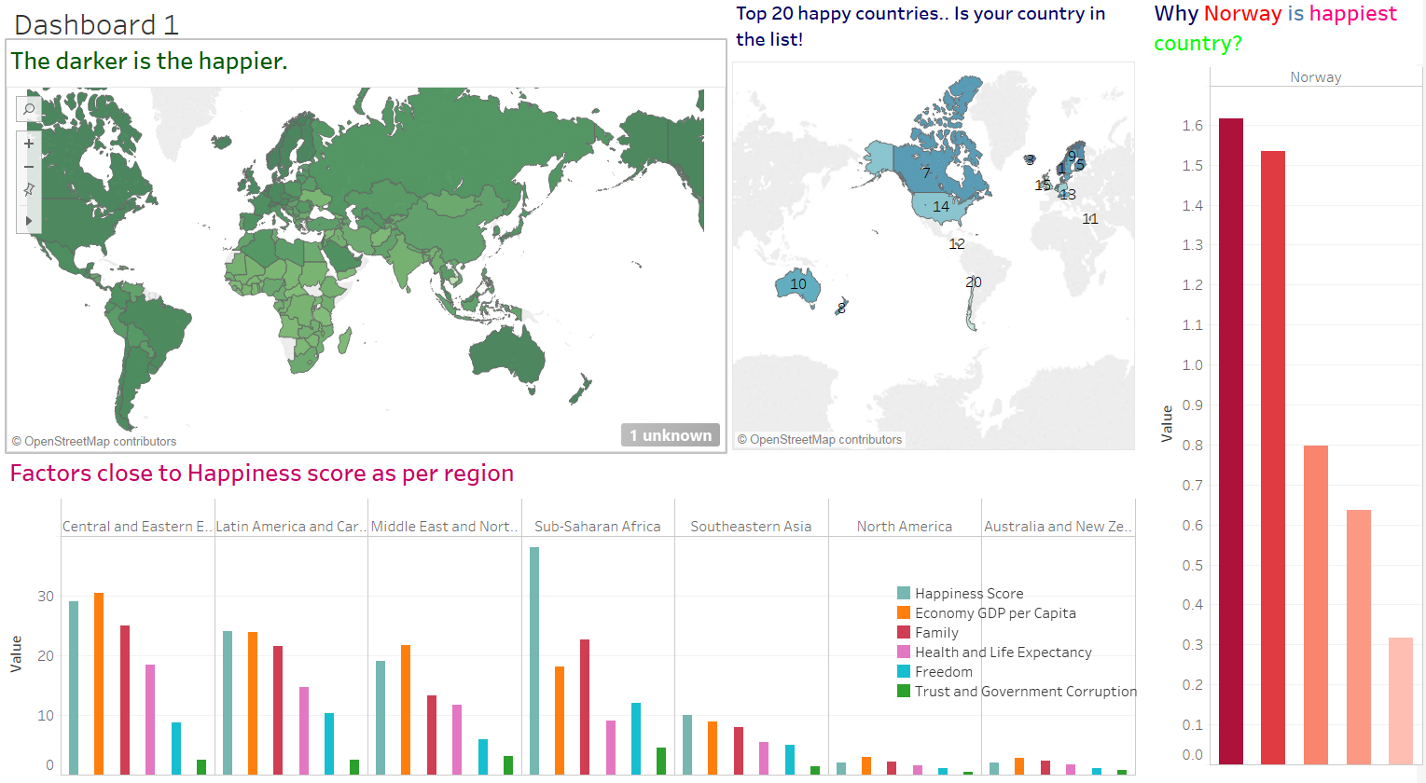

**Final Graph:**

Points of improvement:

Removed two maps from dashboard.

Used common colours for happiness factors.

Removed extra ink from dashboard.

Added Title for dashboard.

**Tableau link:** <https://public.tableau.com/profile/rupal1308#!/vizhome/Assignment3_1_14/Dashboard1?publish=yes>

